Kubernetes Task

Install MiniKube:
curl -LO https://storage.googleapis.com/minikube/releases/latest/minikube-linux-amd64
sudo install minikube-linux-amd64 /usr/local/bin/minikube

minikube version

curl -LO "https://dl.k8s.io/release/$(curl -L -s https://dl.k8s.io/release/stable.txt)/bin/linux/amd64/kubectl"
sudo install kubectl /usr/local/bin/kubectl

kubectl version –client

minikube start

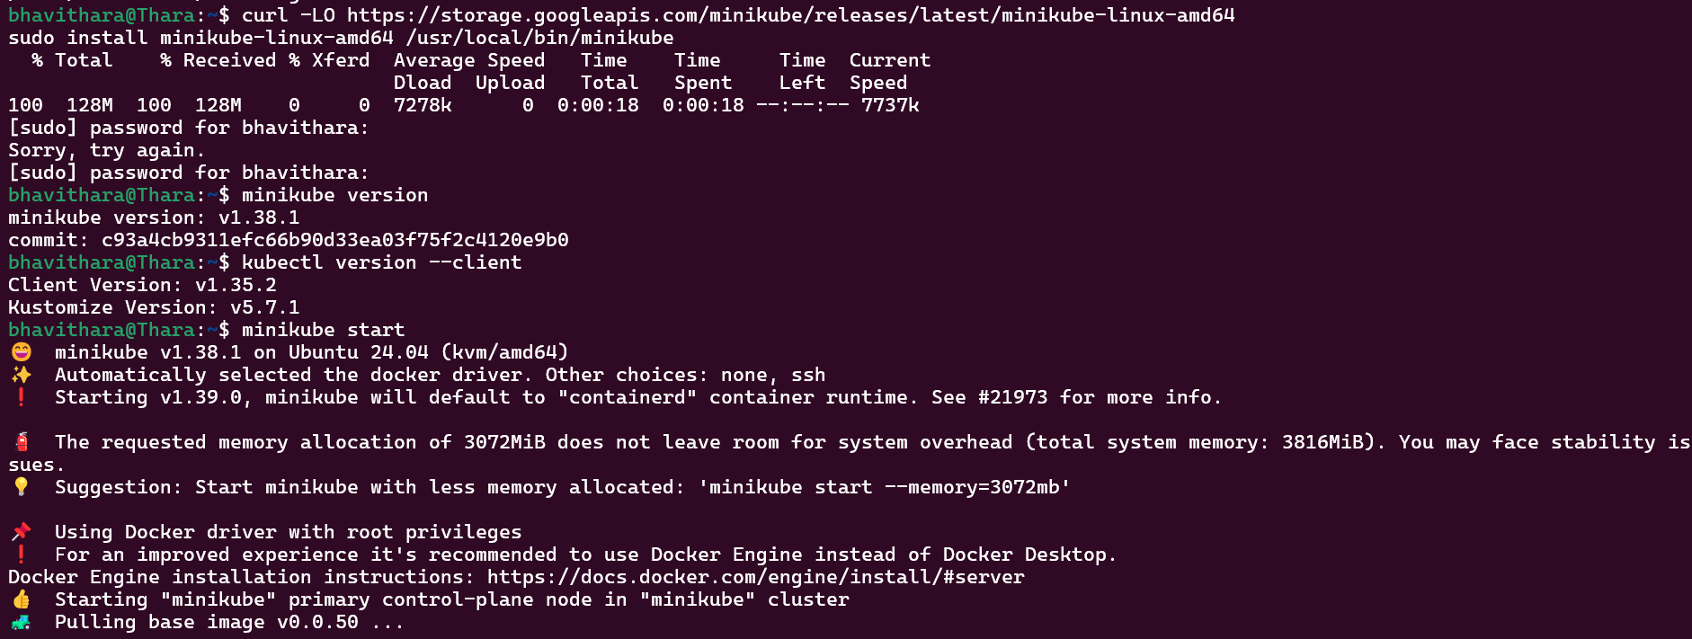

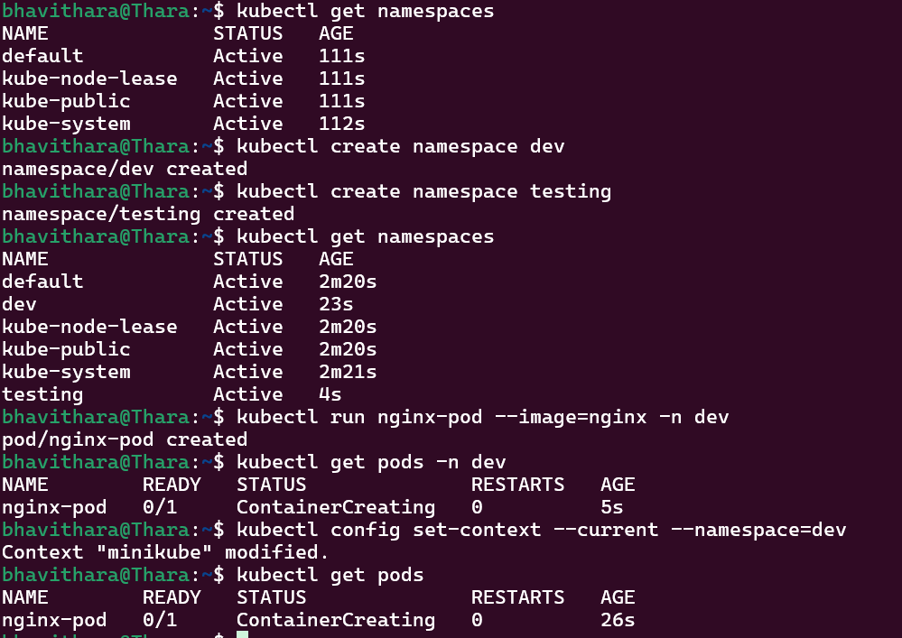

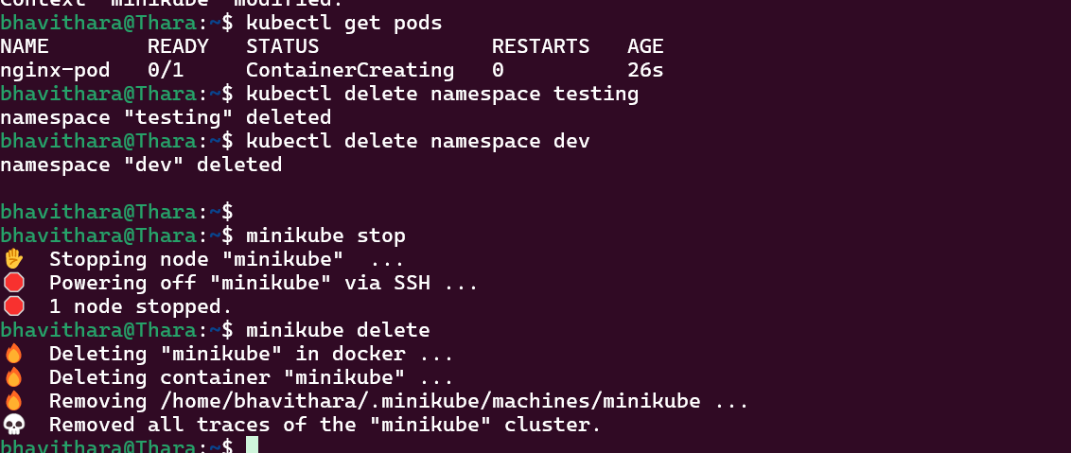

Commands Used:
minikube start
kubectl get namespaces
kubectl create namespace dev
kubectl create namespace testing
kubectl run nginx-pod --image=nginx -n dev
kubectl get pods -n dev
kubectl delete namespace testing

